UNIT – I

1. What is Artificial Intelligence?
2. Artificial Intelligence is a field that aims to make humans more intelligent
3. Artificial Intelligence is a field that aims to improve the security
4. Artificial Intelligence is a field that aims to develop intelligent machines
5. Artificial Intelligence is a field that aims to mine the data
6. Which of the following is the branch of Artificial Intelligence?
7. Machine Learning
8. Cyber forensics
9. Full-Stack Developer
10. Network Design
11. What is the goal of Artificial Intelligence?
12. To solve artificial problems
13. To extract scientific causes
14. To explain various sorts of intelligence
15. To solve real-world problems
16. Which of the following is an application of Artificial Intelligence?
17. It helps to exploit vulnerabilities to secure the firm
18. Language understanding and problem-solving (Text analytics and NLP)
19. Easy to create a website
20. It helps to deploy applications on the cloud
21. What is the function of an Artificial Intelligence “Agent”?
22. Mapping of goal sequence to an action
23. Work without the direct interference of the people
24. Mapping of precept sequence to an action
25. Mapping of environment sequence to an action
26. Which of the following is not a type of Artificial Intelligence agent?  
    a) Learning AI agent  
    b) Goal-based AI agent  
    c) Simple reflex AI agent  
    d) Unity-based AI agent
27. Which of the following is an advantage of artificial intelligence?  
    a) Reduces the time taken to solve the problem  
    b) Helps in providing security  
    c) Have the ability to think hence makes the work easier  
    d) All of the above
28. Which of the following is/are the composition for AI agents?  
    a) Program only  
    b) Architecture only  
    c) Both Program and Architecture  
    d) None of the mentioned
29. Mention four examples of artificially intelligent applications in our smartphones.
30. How does a machine become Artificially Intelligent?
31. Mention four examples of machines that are smart but not AI.
32. What is meant by robotic agent?
33. Define rational agent?
34. What is the role of agent program?
35. List down the characteristics of intelligent agent?
36. State the concept of rationality?
37. what are the four components to define a problem? Define them
38. How will you measure the problem-solving performance?
39. Differentiate uniformed and informed search?
40. List some of the uninformed search techniques.
41. What are the capabilities, computer should posses to pass Turing test?
42. What is important for task environment?
43. Define Percept Sequence.
44. What is game playing?
45. What is Mini –Max Strategy?
46. Define pruning
47. Define abstraction

**Brief questions**

1. Briefly explain the various properties of task environment.
2. **Explain in detail, the structure of different intelligent agents with suitable diagrams.**
3. **What is an agent? Explain the basic kinds of agent program.**
4. Explain how AI works in the following areas:
5. Google Search Engine
6. b. Voice Assistants
7. Justify with reason How has AI changed the gaming world?
8. What is Intelligence? Explain in brief any three types of intelligence that are mainly perceived by human beings?
9. How can AI be integrated with non-AI technologies? Explain with the help of an example.
10. How intelligent robots are helping us in accomplishing dangerous jobs?
11. What is the application of BFS?
12. State on which basis search algorithms are chosen?
13. Evaluate performance of problem-solving method based on depth-first search algorithm?
14. **What are the advantages of Breadth First Search?**
15. **What are the advantages of Depth First Search?**
16. Given a 3×3 board with 8 tiles (every tile has one number from 1 to 8) and one empty space. The objective is to place the numbers on tiles to match the final configuration using the empty space. We can slide four adjacent (left, right, above, and below) tiles into the empty space.

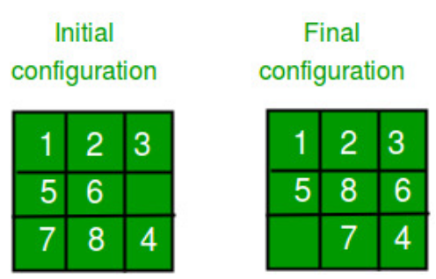

perform a depth-first search on state-space (Set of all configurations of a given problem i.e. all states that can be reached from the initial state) tree.

UNIT – II

Short answer:

1. What is the other name of informed search strategy?  
a) Simple search  
b) Heuristic search  
c) Online search  
d) None of the mentioned

2. How many types of informed search method are in artificial intelligence?  
a) 1  
b) 2  
c) 3  
d) 4

3. Which search uses the problem specific knowledge beyond the definition of the problem?  
a) Informed search  
b) Depth-first search  
c) Breadth-first search  
d) Uninformed search

4. Which function will select the lowest expansion node at first for evaluation?  
a) Greedy best-first search  
b) Best-first search  
c) Depth-first search  
d) None of the mentioned

5. What is the heuristic function of greedy best-first search?  
a) f(n) != h(n)  
b) f(n) < h(n)  
c) f(n) = h(n)  
d) f(n) > h(n)

6. Which search uses only the linear space for searching?  
a) Best-first search  
b) Recursive best-first search  
c) Depth-first search  
d) None of the mentioned

7. Which method is used to search better by learning?  
a) Best-first search  
b) Depth-first search  
c) Metalevel state space  
d) None of the mentioned

8. Which search is complete and optimal when h(n) is consistent?  
a) Best-first search  
b) Depth-first search  
c) Both Best-first & Depth-first search  
d) A* search

9. Which is used to improve the performance of heuristic search?  
a) Quality of nodes  
b) Quality of heuristic function  
c) Simple form of nodes  
d) None of the mentioned

10. Which search method will expand the node that is closest to the goal?  
a) Best-first search  
b) Greedy best-first search  
c) A* search  
d) None of the mentioned

11. Why does one go for heuristics search?

12. What are the advantages of heuristic function?

13. When a heuristic function h is said to be admissible? Give an admissible heuristic function for

TSP?

14. What is heuristic search and function

**15. What is Local Maxima?**

16. Differentiate simple hill Climbing and Steepest Hill climbing.

Brief Questions

17. Explain the A* search and give the proof of optimality of A*

18. Explain how the steepest accent hill climbing works and Heuristic Functions?

19. Write in detail about Generate and Test and Simple Hill Climbing

**20. Explain AO* algorithm with a suitable example. State the limitations in the algorithm?**

**21. Explain alpha-beta pruning algorithm and the Minmax game playing algorithm with example?**

22. Solve the following problem using alpha-beta pruning algorithm

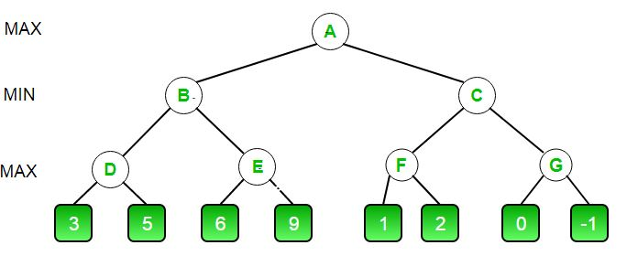

1. Solve the following problem using alpha-beta pruning algorithm

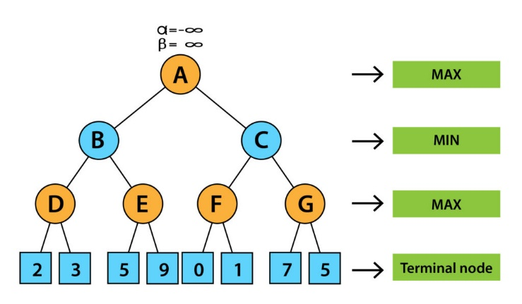

**24. Explain the nature of heuristics with example. What is the effect of heuristics accuracy?**

25. Consider the following graph-The numbers written on edges represent the distance between the nodes. The numbers written on nodes represent the heuristic value. Find the most cost-effective path to reach from start state A to final state J using A* Algorithm.

